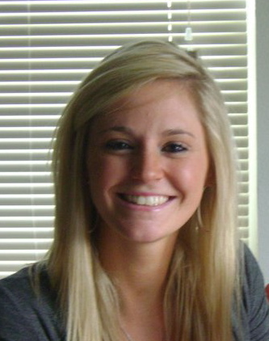

My name is Gabby Eddings; I am a DVM candidate for the Class of 2015 at Washington State University. I am from a small town in central Washington known for its hay production and annual rodeo. Growing up I participated in 4-H from the moment I was old enough to show swine and continued through high school. Along with 4-H, I was an involved member in my FFA chapter as an officer and obtaining my American Degree in Swine Production. I received my Bachelor’s of Science in Animal Sciences here at Washington State University as well. I have numerous experiences with agricultural animal production systems, including small-scale cow-calf operations, small-scale show swine production, and intensive commercial confinement swine production. I have been a Public Health Veterinary Intern for USDA Food Safety and Inspection Services (FSIS) agency the past two summers. Preceding this internship, as an undergraduate I was employed as a food inspector intern with the agency. I have worked in two high-speed cattle plants and a high volume lamb plant. While I have been an intern with USDA, I have also had the opportunity to shadow veterinarians and Consumer Safety Inspectors at cull swine plants, a small veal plant, and numerous processing plants. Being an intern with USDA FSIS sparked my interest in public health and has solidified the career path I want to pursue after the completion of my degree.

